**SITE SPECIFIC DATA**

WDID = point of diversion. Can have 1 to many water rights. Can also have 1 to many Diversion Records. Diversion records **do not** connect to the Water Right.

Diversion records = physical world.

Probably going to pull this data once a year, around June.

**Query by Division.** What are their divisions again? 1-7

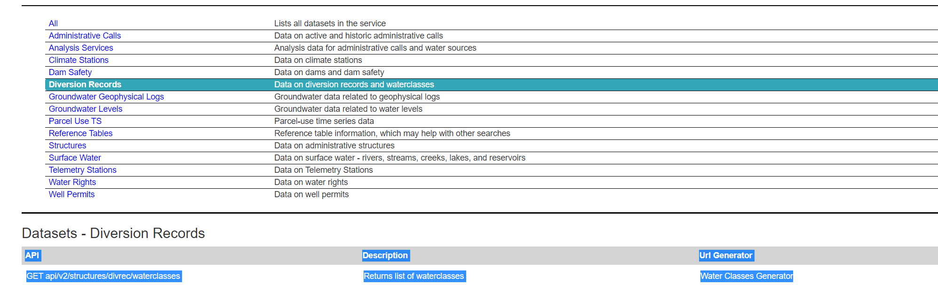

Then query by WDID (you can pass in a csv list instead of individually). What is the char limit on this?

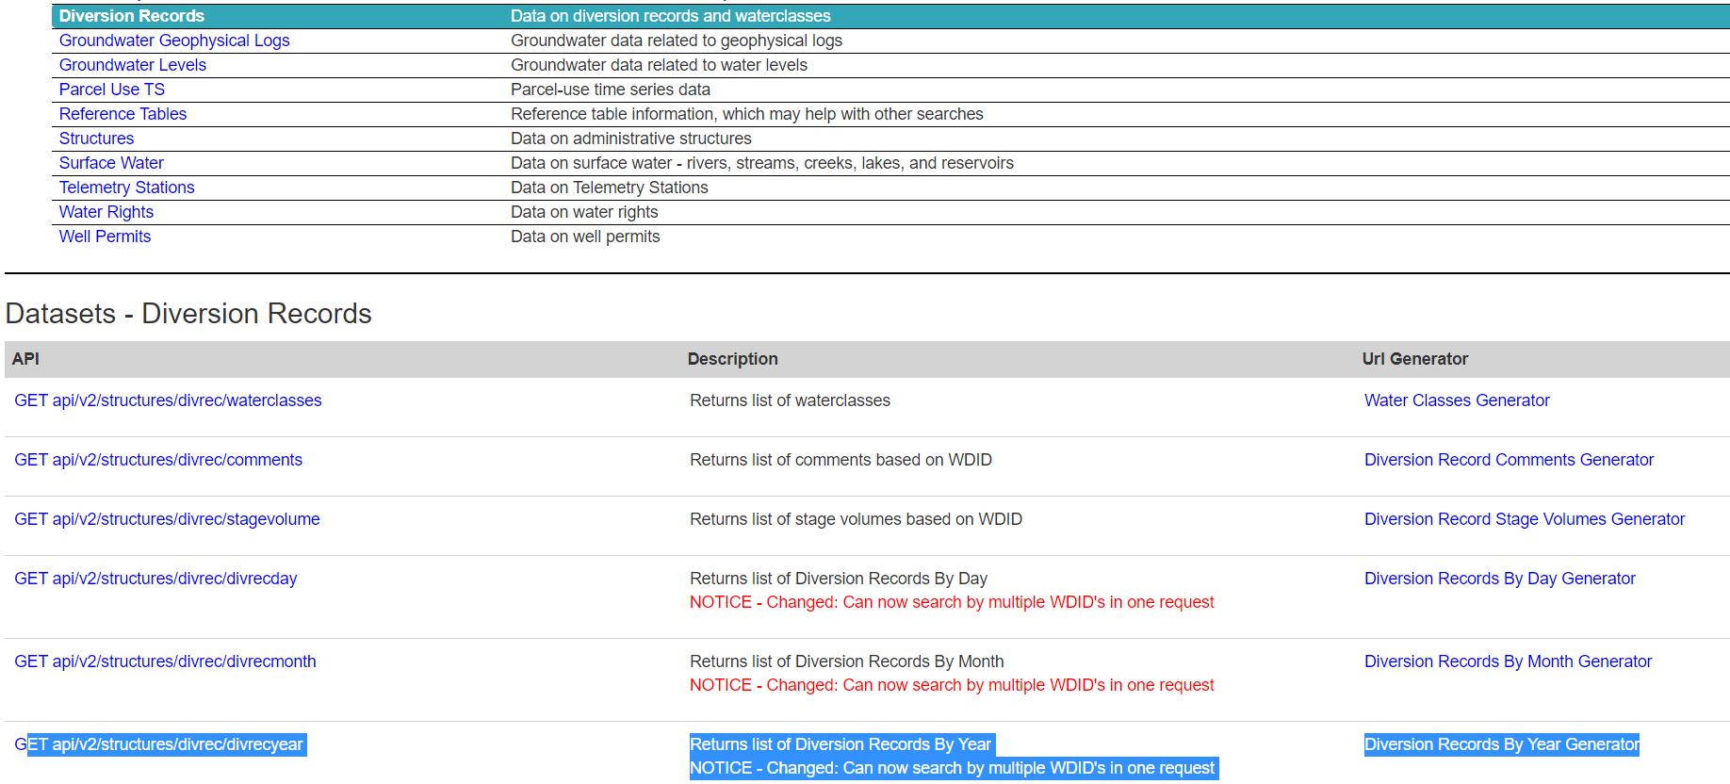

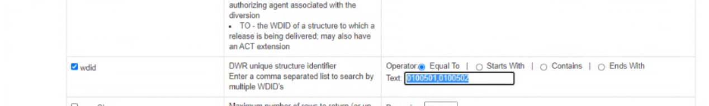

The resulting data set will say how it was indicated (so if we get annual, it might say it was measured by day, but still works).

**WATER RIGHTS**

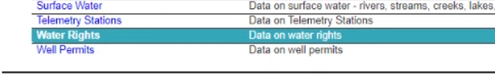

Be aware of their net amount water rights have some problem (issue that the data does not have a record of the true diversion). It’s okay for now, just might need that disclaimer.

CO does not track ownership of water rights (legally they can’t). They have ‘contacts’, but now owners.

How do we pick the ‘primary’ beneficial use when we color? Probably best to start with agriculture, then work your way down.